Semester End Practical Examination JAN 2021-JUNE 2021

B.Sc. (Prog.) Physical Science

Paper Code: **42347903**

Paper Name: **Internet Technologies**

**Set – A**

**College Roll No. – 2018PSC1002**

**Examination Roll No. – 18068582001**

Q1

<%@ page language=*"java"* contentType=*"text/html; charset=ISO-8859-1"*

pageEncoding=*"ISO-8859-1"*%>

<%@page import = *"java.util.logging.Logger"* %>

<!DOCTYPE html>

<html>

<head>

<meta charset=*"ISO-8859-1"*>

<title>SUM</title>

<%! **int** a=3 ,b=4 ; %> <%--Initialising values of a and b --%>

<%!

**int** sum (**int** x , **int** y)

{

**return** x+y;

}%> <%--method to add two numbers and returns sum --%>

</head>

<body>

Sum of 3 and 4 is <%=sum(a,b) %> .<%--this will print the sum in web browser --%>

<%

**int** res = sum(a,b);

System.out.println("Sum of 3 and 4 is " + sum(a,b)+ ".");

%> <%--this will print the statement in console --%>

</body>

</html>

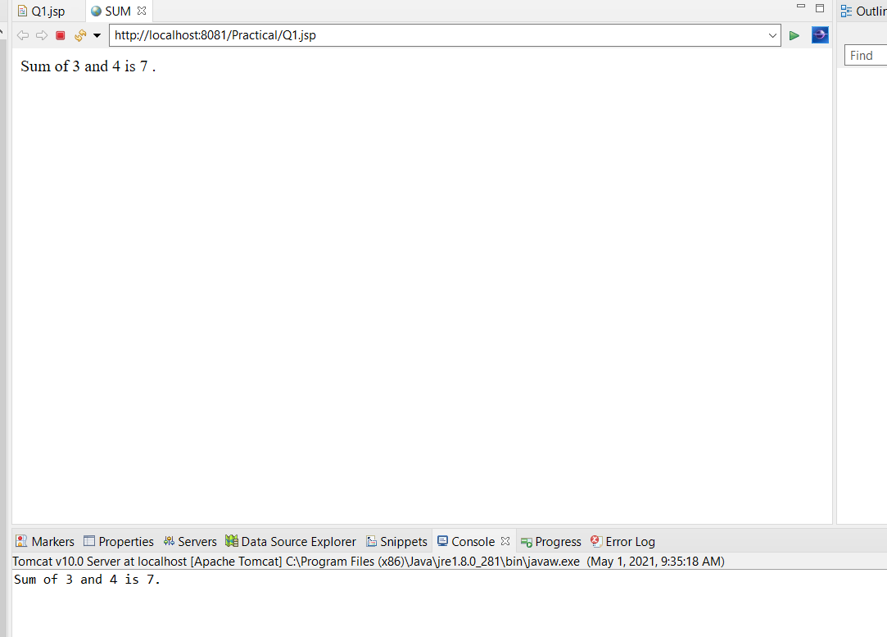

Q2.

**Q2.jsp**

<%@ page language=*"java"* contentType=*"text/html; charset=ISO-8859-1"*

pageEncoding=*"ISO-8859-1"*%>

<!DOCTYPE html>

<html>

<head>

<meta charset=*"ISO-8859-1"*>

<title>REGISTRATION FORM</title>

<link href=*"Q2.css"* rel=*"stylesheet"* type=*"text/css"* media=*"all"* />

</head>

<body>

<div class=*"head"*>EMPLOYEE REGISTRATION FORM</div>

<form action=*"Q2a.jsp"* method=*"post"*>

<fieldset>

<br> First Name <br> <input type=*"text"* name=*"fname"*

placeholder=*"John"* required> <br> <br>Last Name <br>

<input type=*"text"* name=*"lname"* placeholder=*"Smith"* required>

<br> <br>Gender <br> <br>Male<input type=*"radio"*

name=*"gender"* value=*"Male"*> Female<input type=*"radio"*

name=*"gender"* value=*"Female"*> Other<input type=*"radio"*

name=*"gender"* value=*"Other"*> <br> <br>Address<br>

<br> State &ensp;

<select name=*"state"*>

<option>-</option>

<option>Andhra Pradesh</option>

<option>Arunachal Pradesh</option>

<option>Assam</option>

<option>Bihar</option>

<option>Chhattisgarh</option>

<option>Goa</option>

<option>Gujarat</option>

<option>Haryana</option>

<option>Himachal Pradesh</option>

<option>Jammu and Kashmir</option>

<option>Jharkhand</option>

<option>Karnataka</option>

<option>Kerala</option>

<option>Madhya Pradesh</option>

<option>Maharashtra</option>

<option>Manipur</option>

<option>Meghalaya</option>

<option>Mizoram</option>

<option>Nagaland</option>

<option>Odisha</option>

<option>Punjab</option>

<option>Rajasthan</option>

<option>Sikkim</option>

<option>Tamil Nadu</option>

<option>Telangana</option>

<option>Tripura</option>

<option>Uttar Pradesh</option>

<option>Uttarakhand</option>

<option>West Bengal</option>

</select> &ensp;City &ensp;

<select name=*"city"*>

<option>-</option>

<option>Adilabad</option>

<option>Agra</option>

<option>Ahmedabad</option>

<option>Ahmednagar</option>

<option>Aizawl</option>

<option>Ajitgarh (Mohali)</option>

<option>Ajmer</option>

<option>Akola</option>

<option>Alappuzha</option>

<option>Aligarh</option>

<option>Alirajpur</option>

<option>Allahabad</option>

<option>Almora</option>

<option>Alwar</option>

<option>Ambala</option>

<option>Ambedkar Nagar</option>

<option>Amravati</option>

<option>Amreli district</option>

<option>Amritsar</option>

<option>Anand</option>

<option>Anantapur</option>

<option>Anantnag</option>

<option>Angul</option>

<option>Anjaw</option>

<option>Anuppur</option>

<option>Araria</option>

<option>Ariyalur</option>

<option>Arwal</option>

<option>Ashok Nagar</option>

<option>Auraiya</option>

<option>Aurangabad</option>

<option>Aurangabad</option>

<option>Azamgarh</option>

<option>Badgam</option>

<option>Bagalkot</option>

<option>Bageshwar</option>

<option>Bagpat</option>

<option>Bahraich</option>

<option>Baksa</option>

<option>Balaghat</option>

<option>Balangir</option>

<option>Bangalore Rural</option>

<option>Bangalore Urban</option>

<option>Banka</option>

<option>Bankura</option>

<option>Banswara</option>

<option>Barabanki</option>

<option>Baramulla</option>

<option>Baran</option>

<option>Bardhaman</option>

<option>Bareilly</option>

<option>Bargarh (Baragarh)</option>

<option>Barmer</option>

<option>Barnala</option>

<option>Barpeta</option>

<option>Barwani</option>

<option>Bastar</option>

<option>Basti</option>

<option>Bathinda</option>

<option>Beed</option>

<option>Begusarai</option>

<option>Belgaum</option>

<option>Bellary</option>

<option>Betul</option>

<option>Bhadrak</option>

<option>Bhagalpur</option>

<option>Bhandara</option>

<option>Bharatpur</option>

<option>Bharuch</option>

<option>Bhavnagar</option>

<option>Bhilwara</option>

<option>Bhind</option>

<option>Bhiwani</option>

<option>North Tripura</option>

<option>North West Delhi</option>

<option>Nuapada</option>

<option>Ongole</option>

<option>Osmanabad</option>

<option>Pakur</option>

<option>Palakkad</option>

<option>Palamu</option>

<option>Pali</option>

<option>Palwal</option>

<option>Panchkula</option>

<option>-Panchmahal</option>

<option>Panchsheel Nagar district (Hapur)</option>

<option>-Panipat</option>

<option>Panna</option>

<option>Papum Pare</option>

<option>Parbhani</option>

<option>Paschim Medinipur</option>

<option>Patan</option>

<option>Pathanamthitta</option>

<option>Pathankot</option>

<option>Patiala</option>

<option>Patna</option>

<option>Pauri Garhwal</option>

<option>Perambalur</option>

<option>Phek</option>

<option>Pilibhit</option>

<option>Pithoragarh</option>

<option>Pondicherry</option>

<option>Poonch</option>

<option>Porbandar</option>

<option>Pratapgarh</option>

<option>Pudukkottai</option>

<option>Pulwama</option>

<option>Pune</option>

<option>Purba Medinipur</option>

<option>Puri</option>

<option>Purnia</option>

<option>Purulia</option>

<option>Raebareli</option>

<option>Raichur</option>

<option>Raigad</option>

<option>Raigarh</option>

<option>Raipur</option>

<option>Raisen</option>

<option>Rajauri</option>

<option>Rajgarh</option>

<option>Rajkot</option>

<option>Rajnandgaon</option>

<option>Rajsamand</option>

<option>Ramabai Nagar (Kanpur Dehat)</option>

<option>Ramanagara</option>

<option>Ramanathapuram</option>

<option>Ramban</option>

<option>Ramgarh</option>

<option>Rampur</option>

<option>Ranchi</option>

<option>Ratlam</option>

<option>Ratnagiri</option>

<option>Rayagada</option>

<option>Reasi</option>

<option>Rewa</option>

<option>Rewari</option>

<option>Ri Bhoi</option>

<option>Rohtak</option>

<option>Rohtas</option>

<option>Rudraprayag</option>

<option>Rupnagar</option>

<option>Sabarkantha</option>

<option>Sagar</option>

<option>Saharanpur</option>

<option>Saharsa</option>

<option>Sahibganj</option>

<option>Saiha</option>

<option>Salem</option>

<option>Samastipur</option>

<option>Samba</option>

<option>Sambalpur</option>

<option>Sangli</option>

<option>Sangrur</option>

<option>Sant Kabir Nagar</option>

<option>Sant Ravidas Nagar</option>

<option>Saran</option>

<option>Satara</option>

<option>Satna</option>

<option>Sawai Madhopur</option>

<option>Sehore</option>

<option>Senapati</option>

<option>Seoni</option>

<option>Seraikela Kharsawan</option>

<option>Serchhip</option>

<option>Shahdol</option>

<option>Shahjahanpur</option>

<option>Shajapur</option>

<option>Shamli</option>

<option>Sheikhpura</option>

<option>Sheohar</option>

<option>Sheopur</option>

<option>Shimla</option>

<option>Shimoga</option>

<option>Shivpuri</option>

<option>Shopian</option>

<option>Shravasti</option>

<option>Sibsagar</option>

<option>Siddharthnagar</option>

<option>Sidhi</option>

<option>Sikar</option>

<option>Simdega</option>

<option>Sindhudurg</option>

<option>Singrauli</option>

<option>Sirmaur</option>

<option>Sirohi</option>

<option>Sirsa</option>

<option>Sitamarhi</option>

<option>Sitapur</option>

<option>Sivaganga</option>

<option>Siwan</option>

<option>Solan</option>

<option>Solapur</option>

<option>Sonbhadra</option>

<option>Sonipat</option>

<option>Sonitpur</option>

<option>South 24 Parganas</option>

<option>South Delhi</option>

<option>South Garo Hills</option>

<option>South Goa</option>

<option>South Sikkim</option>

<option>South Tripura</option>

<option>South West Delhi</option>

<option>Sri Muktsar Sahib</option>

<option>Srikakulam</option>

<option>Srinagar</option>

<option>Subarnapur (Sonepur)</option>

<option>Sultanpur</option>

<option>Sundergarh</option>

<option>Supaul</option>

<option>Surat</option>

<option>Surendranagar</option>

<option>Surguja</option>

<option>Tamenglong</option>

<option>Tarn Taran</option>

<option>Tawang</option>

<option>Tehri Garhwal</option>

<option>Thane</option>

<option>Thanjavur</option>

<option>The Dangs</option>

<option>Theni</option>

<option>Thiruvananthapuram</option>

<option>Thoothukudi</option>

<option>Thoubal</option>

<option>Thrissur</option>

<option>Tikamgarh</option>

<option>Tinsukia</option>

<option>Tirap</option>

<option>Tiruchirappalli</option>

<option>Tirunelveli</option>

<option>Tirupur</option>

<option>Tiruvallur</option>

<option>Tiruvannamalai</option>

<option>Tiruvarur</option>

<option>Tonk</option>

<option>Tuensang</option>

<option>Tumkur</option>

<option>Udaipur</option>

<option>Udalguri</option>

<option>Udham Singh Nagar</option>

<option>Udhampur</option>

<option>Udupi</option>

<option>Ujjain</option>

<option>Ukhrul</option>

<option>Umaria</option>

<option>Una</option>

<option>Unnao</option>

<option>Upper Siang</option>

<option>Upper Subansiri</option>

<option>Uttar Dinajpur</option>

<option>Uttara Kannada</option>

<option>Uttarkashi</option>

<option>Vadodara</option>

<option>Vaishali</option>

<option>Valsad</option>

<option>Varanasi</option>

<option>Vellore</option>

<option>Vidisha</option>

<option>Viluppuram</option>

<option>Virudhunagar</option>

<option>Visakhapatnam</option>

<option>Vizianagaram</option>

<option>Vyara</option>

<option>Warangal</option>

<option>Wardha</option>

<option>Washim</option>

<option>Wayanad</option>

<option>West Champaran</option>

<option>West Delhi</option>

<option>West Garo Hills</option>

<option>West Kameng</option>

<option>West Khasi Hills</option>

<option>West Siang</option>

<option>West Sikkim</option>

<option>West Singhbhum</option>

<option>West Tripura</option>

<option>Wokha</option>

<option>Yadgir</option>

<option>Yamuna Nagar</option>

<option>Yanam</option>

<option>Yavatmal</option>

<option>Zunheboto</option>

</select>

<br> <br>House No.

<br> <input type=*"text"* name=*"hno"*placeholder=*"House Number"*>

Pin Code &ensp;

<br> <input type=*"number"* name=*"pcode"* placeholder=*"XXXXXX"*> <br> <br>

DOB &ensp;

<br> <input type=*"date"* name=*"dob"*placeholder=*"yyyy-mm-dd"*>

<br> <br> Salary(p.a)

&ensp;<br> <input type=*"number"* name=*"salary"*> <br>

<br> Age &ensp;&ensp;<br>

<input type=*"number"* name=*"age"*>

<br> <br> Phone. No. &ensp;

<br> <input type=*"number"* name=*"phno"*>

<button type=*"submit"* value=*"Register"*>Register</button>

</fieldset>

</form>

</body>

</html>

**Q2.css**

@charset *"ISO-8859-1"*;

*.head*{

position:*absolute*;

font-style : *"Times-New-Roman"*;

font-weight : *bolder*;

font-size : *40px*;

color : *rgb(200,* *100,* *0)*;

left : *450px*;

top : *30px*;

}

**body**{

background-image:*url("https://nayainsurancetax.com/wp-content/uploads/2019/01/insurance-quote-form-background-fontana-ca.jpg")*;

}

**input**{

width : *100%*;

padding: *12px* *20px*;

margin: *8px* *0*;

box-sizing: *border-box*;

}

**select**{

width : *100%*;

padding: *12px* *20px*;

margin: *8px* *0* ;

box-sizing: *border-box*;

}

**form**{

color : *#FBA892*;

background-color : *"black"*;

font-size : *20px*;

}

**fieldset**{

position : *absolute*;

left : *500px*;

top : *130px*;

background-image : *url("https://i0.wp.com/css-tricks.com/wp-content/uploads/2018/08/vector.png?ssl=1")*

}

**button**{

position : *absolute*;

top : *1290px*;

left : *210px*;

font-size : *30px*;

background : *black*;

color : *white*;

}

**Q2a.jsp**

<%@ page language=*"java"* contentType=*"text/html; charset=ISO-8859-1"*

pageEncoding=*"ISO-8859-1"*%>

<%@ page import=*"java.sql.*"* %>

<%@ page import=*"java.io.*"*%>

<%@ page import=*"java.util.*"* %>

<%@ page import=*"q2.Employee"* %>

<!DOCTYPE html>

<html>

<head>

<meta charset=*"ISO-8859-1"*>

<title>OUTPUT</title>

</head>

<body>

<jsp:useBean id=*'emp'* class=*'q2.Employee'* scope=*'session'*/>

<jsp:setProperty name=*'emp'* property=*'*'*/>

Employee name is <jsp:getProperty name=*"emp"* property=*"fname"*/>

<br>

Employee age is <jsp:getProperty name=*"emp"* property=*"age"*/>

<%

**try**

{

Class.forName("com.mysql.cj.jdbc.driver");

Connection con = DriverManager.getConnection("jdbc:mysql://localhost:3306/employee","root","root");

Statement st = con.createStatement();

String sql = "insert into employee(FName,Age,Lname,Gender,State,City,Hno,Pcode,Salary,Phno,Dob)values(?,?,?,?,?,?,?,?,?,?,?)";

PreparedStatement pst = con.prepareStatement(sql);

pst.setString(1, emp.getFname());

pst.setInt(2,emp.getAge());

pst.setString(3,emp.getLname());

pst.setString(4,emp.getGender());

pst.setString(5,emp.getState());

pst.setString(6,emp.getCity());

pst.setString(7,emp.getHno());

pst.setInt(8,emp.getPcode());

pst.setInt(9,emp.getSalary());

pst.setInt(10,emp.getPhno());

pst.setInt(11, emp.getDob());

pst.executeUpdate();

con.close();

} **catch** (Exception e) {

System.out.print(e);

e.printStackTrace();

}

%>

</body>

</html>

**Emloyee.java**

**package** q2;

**public** **class** Employee {

**private** String fname;

**private** String lname;

**private** String gender;

**private** String state;

**private** String city;

**private** String hno;

**private** **int** pcode;

**private** **int** salary;

**private** **int** phno;

**private** **int** age;

**private** **int** dob;

**public** **int** getDob() {

**return** dob;

}

**public** **void** setDob(**int** dob) {

**this**.dob = dob;

}

**public** **int** getAge() {

**return** age;

}

**public** **void** setAge(**int** age) {

**this**.age = age;

}

**public** String getFname() {

**return** fname;

}

**public** **void** setFname(String fname) {

**this**.fname = fname;

}

**public** String getLname() {

**return** lname;

}

**public** **void** setLname(String lname) {

**this**.lname = lname;

}

**public** String getGender() {

**return** gender;

}

**public** **void** setGender(String gender) {

**this**.gender = gender;

}

**public** String getState() {

**return** state;

}

**public** **void** setState(String state) {

**this**.state = state;

}

**public** String getCity() {

**return** city;

}

**public** **void** setCity(String city) {

**this**.city = city;

}

**public** String getHno() {

**return** hno;

}

**public** **void** setHno(String hno) {

**this**.hno = hno;

}

**public** **int** getPcode() {

**return** pcode;

}

**public** **void** setPcode(**int** pcode) {

**this**.pcode = pcode;

}

**public** **int** getSalary() {

**return** salary;

}

**public** **void** setSalary(**int** salary) {

**this**.salary = salary;

}

**public** **int** getPhno() {

**return** phno;

}

**public** **void** setPhno(**int** phno) {

**this**.phno = phno;

}

}

